Nova – Software to provision virtual machines on standard hardware at massive scale.

**nova-api** – accept and fulfill incoming API request. Provides an endpoint for all API queries.

By default, nova-api listens on port 8773 for the EC2 API and 8774 for the OpenStack API.

**nova-scheduler** - it takes a virtual machine instance request from the queue and determines where it should run (specifically, which compute server host it should run on)

|  |  |
| --- | --- |
| Simple | Attempts to find least loaded host. |
| Chance | Chooses random available host from service table. This is the default scheduler. |
| Zone | Picks random host from within an availability zone. |

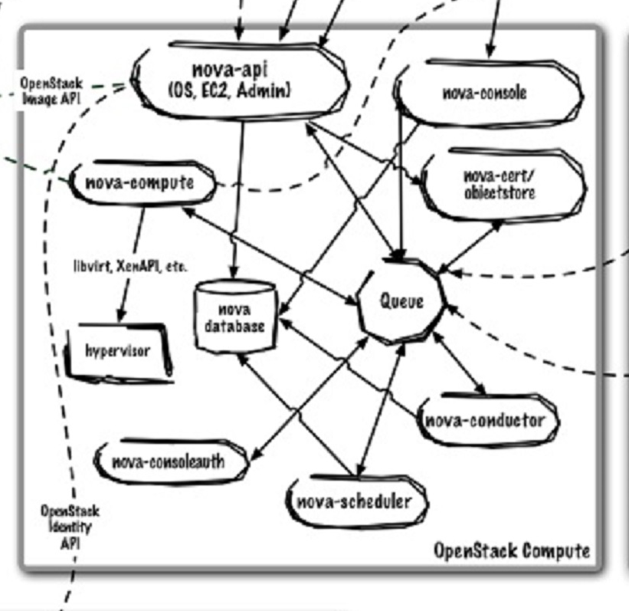Neutron

Horizon Python Amazon API Server VNC/VMRC Glance api cinder volume cinder scheduler

Identity(Keystone) API

**nova-compute** - primarily a worker daemon that creates and terminates virtual machine instances.

Note – documentation says it also updates the DB but that is not referenced here? Does this happen via conductor? YES!

Can Nova support multiple virtualizations at once? Hyper-V, VMware???

An example of this would be nova-compute accepting a message from the queue to create a new instance and then using the libvirt library to start a new KVM instance.

**libvirt** - This is a toolkit (API, daemon, and utilities) created by Red Hat to interact with the capabilities of a wide range of Linux virtualization technologies. In this case it is used to manage virtual machines.

Whilelibvirt may be the most common, nova-compute also uses the Xen API, vSphere API, Windows Management Interface, and others to support other virtualization technologies.

**nova-network** - It accepts networking tasks from the queue and then performs system commands to manipulate the network (such as setting up bridging interfaces or changing iptables rules). (Not in the diagram above?)

Fixed IPs - assigned on instance startup and remain the same during their entire lifetimes.

Floating IPs - dynamically allocated and associated to a domain to allow outside connectivity.

Nova supports 3 networking managers:

Flat - Each new instance is assigned a fixed IP address and attached to a common bridge (which must be created by the administrator). IP configuration information must be “injected” (written into the new instance virtual disk image) to configure the instance.

FlatDHCP - builds upon the Flat manager by providing DHCP services to handle instance addressing and creation of bridges.

VLAN - In this mode, nova-network creates a VLAN, a subnet, and a separate bridge for each project. Each project also receives a range of IP only accessible within the VLAN.

**Queue** - The queue provides a central hub for passing messages between daemons. This is currently implemented with [RabbitMQ](http://www.rabbitmq.com/) today, but theoretically could be any [AMPQ message queue](http://www.amqp.org/confluence/display/AMQP/Advanced+Message+Queuing+Protocol) supported by the Python [ampqlib](http://barryp.org/software/py-amqplib/) and [carrot](http://ask.github.com/carrot/) libraries.

**nova database** - The database stores most of the configuration and run-time state for a cloud infrastructure. This includes the instance types that are available for use, instances in use, networks available, and projects.

What DB do we use for nova? What is setup in the POC? sqlite3 is not prod ready.

**nova-console** - XenAPI-specific service that most recent VNC proxy architectures do not use.

**nova-consoleauth** - client proxies leverage a shared service to manage token authentication. This service must be running for proxy to work.

**nova-conductor** - service enables OpenStack to function without compute nodes accessing the database. Conceptually, it implements a new layer on top of nova-compute. It should not be deployed on compute nodes, or else the security benefits of removing database access from nova-compute are negated. Just like other nova services such as nova-api or nova-scheduler, it can be scaled horizontally. You can run multiple instances of nova-conductor on different machines as needed for scaling purposes.

**nova-cert** - nova-cert is a server daemon that serves the Nova Cert service for X509 certificates. Used to generate certificates for euca-bundle-image. Only needed for EC2 API.

**nova-objectstore** – not needed if you have swift. (Note – still used for caching some EC2 stuff)

**nova-volume** – manages the creation, attaching, and detaching of persistent volumes to compute instances (similar in functionality to [Amazon’s Elastic Block Storage](http://aws.amazon.com/ebs/)). It can use volumes from a variety of providers such as iSCSI or AoE. (Not in the diagram above?) – this is now Cinder, a separate open stack project.

**Helpful links**

<https://www.safaribooksonline.com/library/view/deploying-openstack/9781449311223/ch04.html>